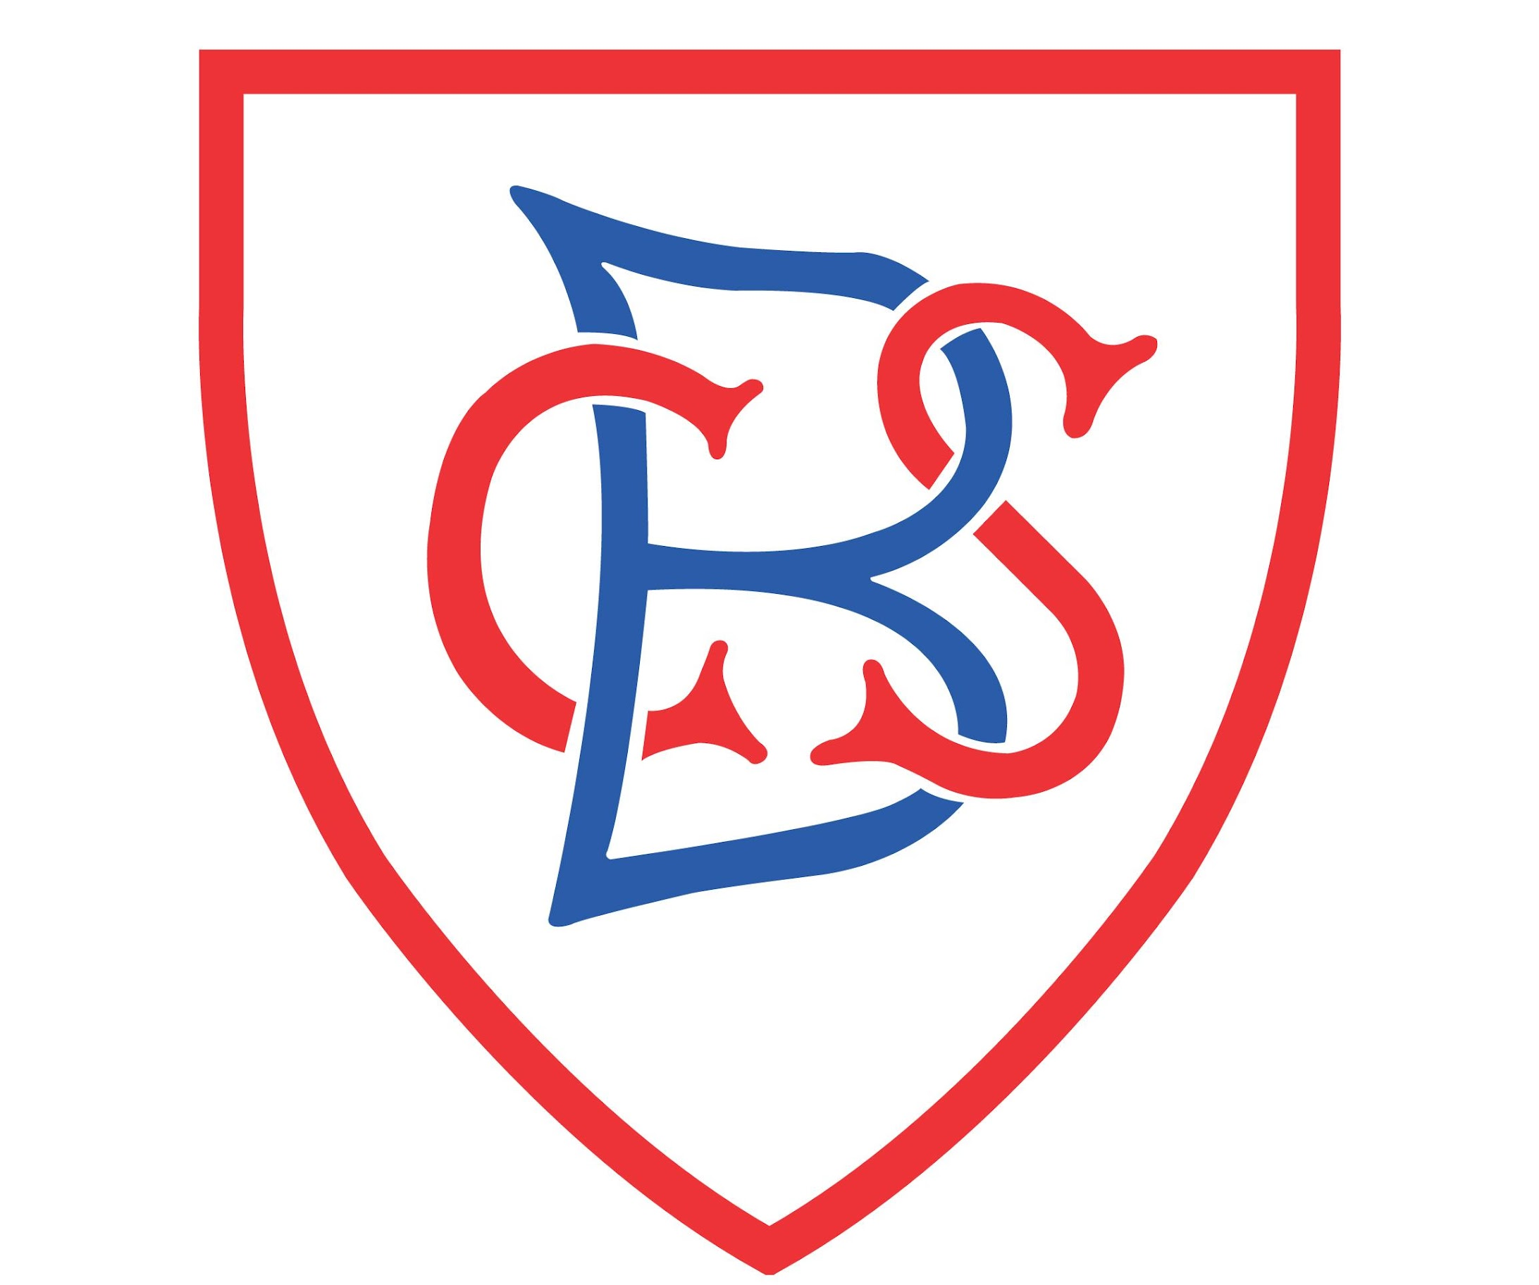

Bowdon Church School

Data Protection Act 2018
Privacy Notice - Parents/Carers

Table of Contents
1.0 Introduction……………………………………………………………………………………………………………...3

2.0 Why do we collect and use pupil information?............................................................3
2.1 Collecting pupil information………………………………………………………………………………..….4
2.2 Storing pupil information……………………………………………………………………………………..…4
2.3 Sharing information……………………………………………………………………………………………..…4

3.0 Requesting access to your personal data…………………………………………………………………..5

4.0 Parent/Carer Information………………………………………………………………………………………….6

5.0 Data Protection Officer……………………………………………………………………………………………..6

Appendices…………………………………………………………………………………………………………………….7
Appendix A - Data Protection Act 2018 Signed Permission Letter - Parent/Carer………………..7

1.0 Introduction

We need to hold personal information about your child on our computers systems and in paper records to help us with their educational needs.

- Your Headteacher is responsible for their accuracy and safe keeping. Please help to keep your child’s records up to date by informing us of any change of circumstances.

- School staff have access to your child’s records to enable them to do their jobs. From time to time information may be shared with others involved in your child’s care, if it is necessary. Anyone with access to your child’s record is properly trained in confidentiality issues and is governed by a legal duty to keep their details secure, accurate and up to date.All information about your child is held securely and appropriate safeguards are in place to prevent loss.

- In some circumstances we may be required by law to release your child’s details to statutory or other official bodies, for example if a court order is present, or in the case of public educational matters. In other circumstances you may be required to give written consent before information is released.

- To ensure your child’s privacy, we will not disclose information over the telephone, fax or email unless we are sure that we are talking to you – the parent /carer. Information will not be disclosed to family and friends unless we have prior consent and we do not leave messages with others.

2.0 Why do we collect and use pupil information
We collect and use pupil information under section 537A of the Education Act 1996, and section 83 of the Children Act 1989. We also ensure we have a lawful basis for processing the data.
We use the pupil data:
- to support pupil learning
- to monitor and report on pupil progress
- to provide appropriate pastoral care
- to assess the quality of our services
- to comply with the law regarding data sharing
- to support you to decide what to do after you leave school

Categories of pupil information that we collect, hold and share include:
- Personal information (such as name, unique pupil number and contact details)
- Characteristics (such as ethnicity, language, nationality, country of birth and free school meal eligibility)
- Attendance information (such as sessions attended, number of absences and absence reasons)
- National curriculum assessment results
- Special educational needs information
- Relevant medical information

2.1 Collecting pupil information
Whilst the majority of pupil information you provide to us is mandatory, some of it is provided to us on a voluntary basis. In order to comply with the Data Protection Regulation, we will inform you whether you are required to provide certain pupil information to us or if you have a choice in this.

2.2 Storing pupil information
The school stores information on several computer and paper-based systems and has set periods for each system for the information to be retained. Should you require further information about which systems, please contact our Data Protection Officer. The longest period that we can hold your child’s information is until the child reaches the age of 25, at which point all data will be removed for our systems.

2.3 Sharing information
There are strict controls on who can see your information. We will not share your data if you have advised us that you do not want it shared unless it is the only way we can make sure you stay safe and healthy or we are legally required to do so. We do not share information about our pupils with anyone without consent unless the law and our policies allow us to do so.
We routinely share pupil information with:
- schools or colleges that the pupils attend after leaving us
- our local authority and their commissioned providers of local authority services
- the Department for Education (DfE)
- Our information is held on a number of systems that have third party access, we have checked with each supplier to ensure they are compliant with General Data Protection Regulations, and that they will not access or use any child data without prior and specific permission from you.
- NHS – To carry out a vital check of health on your child(ren), You will always be informed when these are taking place and in the circumstance where non-statutory data is requested.
- Where applicable with Multi Academy Trust, Academies and Federations
- School Nurse
- Safeguarding Services
- Services Providing Activities

We share pupils’ data with the Department for Education (DfE) on a statutory basis. This data sharing underpins school funding and educational attainment policy and monitoring. This list is non Exhaustive and may branch into several other services and providers, to find out more about the data collection requirements placed on us by the DfE (for example; via the school census) go to https://www.gov.uk/education/data-collection-and-censuses-for-schools
We are required to share information about our pupils with the DfE under regulation 5 of The Education (Information About Individual Pupils) (England) Regulations 2013.

3.0 Requesting access to your personal data

Under General Data Protection Regulations, parents and pupils have the right to request access to information about them that we hold. To make a request for your personal information, or be given access to your child’s educational record, please contact our data protection officers directly, who will arrange for this to happen within the required time.

You also have the right to:
- object to processing of personal data that is likely to cause, or is causing, damage or distress
- prevent processing for the purpose of direct marketing
- object to decisions being taken by automated means
- in certain circumstances, have inaccurate personal data rectified, blocked, erased or destroyed; and
- claim compensation for damages caused by a breach of the Data Protection regulations

4.0 Parent / Carer information
The School will also store basic information such as name, relationship and contact details for all parents / carers on our system so that we can contact you, and to help maintain the safety of our children. We will retain this information for the period that your child is at the school. This data will also be subject to the conditions as outlined in this notice.

5.0 Data Protection Officer
The school has an independent data protection officer service supplied by Global Policing Limited. Global Policing is an organisation run by ex-senior police officers who specialise in working with schools and have vast experience of data protection matters. If you have any questions or comments, or wish to make any requests under the Regulations, you should contact them directly:
- Telephone (answerphone) 0161 212 1682
- Email data@globalpolicing.co.uk
- Website www.globalpolicing.co.uk/data
Please note that should you instigate any of your rights under this act, your basic information will be shared with the data protection office who will make contact with you to support your through the processes and procedures.
If you have a concern about the way we are collecting or using personal data, we ask that you raise your concern with us in the first instance. Alternatively, you can contact the Information Commissioner’s Office at https://ico.org.uk/concerns

Appendices
Appendix A - Data Protection Act 2018 Signed Permission Letter - Parent/Carer

Data Protection Act 2018
Signed Permission - Parent/Carer
You must read the information supplied above and return this signed document to the school.

I am the parent / carer of Class

(If you have more than one child in school, please complete one sheet per child)
Specific Additions:
I give permission to the school to use / take images of my child, and for these to be displayed in the school with the name of the child and outside of the school for example on the school website.
I give permission for my child’s medical information, including allergies to be displayed within the school, which will include the child’s name and picture to ensure that all staff are aware of any specific medical needs.
Permission to display child’s name with picture throughout the school to help with educational purposes and celebrations.
Permissions to display children’s names and pictures on the website.
Permissions to display children’s pictures only on the website.
Permission to display child’s name with birthday, so we can celebrate your children’s birthday.

Permission to share children’s information, and relevant health information with sports providers so they can deliver services in school.

Permission to share children’s information with third parties’ organisations when we go on trips and events to meet health and safety requirements.

Permissions to share detailed information when your child attends a residential, to ensure that your child is kept safe, and this will include medical information, which will be returned to the school afterwards.
Permissions to share basic class lists, including names to NHS commissioned organisations who will then seek permissions from you to carryout checks on children. Please note that on some occasions we are legally required to do this.
Permission to use children’s names on social media e.g. twitter
Permission to use children’s pictures on social media e.g. twitter
Permission to use children’s pictures in newspapers or external publications

Permission to share information with high schools / new schools, when your child transfers to them, which may be done verbally or physically.

Permission to share your child’s name and basic details with third party learning resources the school purchases to facilitate learning.

Name |  | Date
Signed

I understand that as the parent / carer, I have the right to give the school permission to hold and use information about me and the children named above.

I also have been made aware of my rights within the General Data Protection Regulations and how I can contact the data protection officers.

Please note that this form will be stored either electronically or a paper copy will be saved and retained until your child leaves the school.

